PID

Composition
The PID is usually the largest document in a PRINCE2 project. It contains the following parts:
- Project definition
One of the most important components of project management is defining what the project will achieve, its objectives, goals, and scope. The desired outcomes are identified and major steps to achieve those outcomes. This becomes the guiding light which leads the project manager along the journey.
- Project approach
The processes and procedures which will be used by the project to accomplish its objectives.

- Business case
Reference til Business case

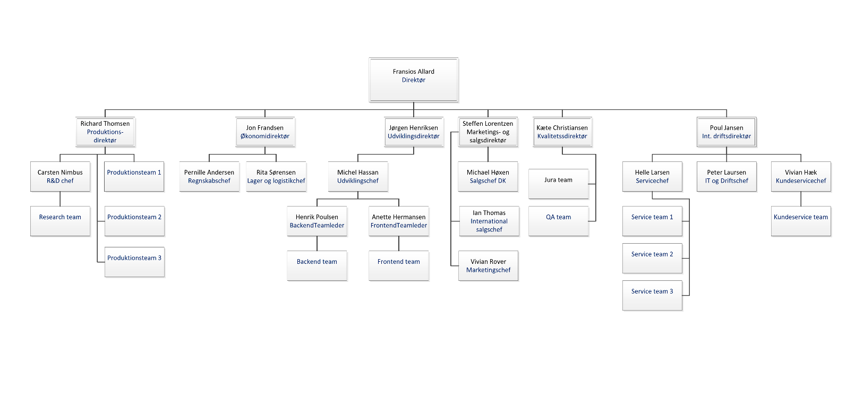
- Project management team structure

- Role descriptions
Reference til Communication management

- Quality management approach
Reference til Quality management

- Change control approach
Reference til Project controls

- Risk management approach
Reference til Risk register

- Communication management approach
Reference til Communication management

- Project plan
Reference til Project plan

- Project controls
Reference til Project controls

Derivation

Reference til Project brief

